Apply rules for Outlook

- Go to File (top left of Outlook) > Manage Rules & Alerts

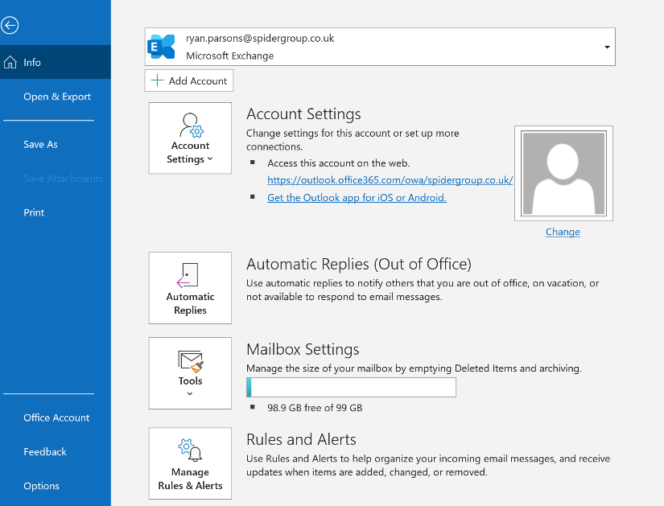

- Select New Rule

- Move Messages From someone to a folder

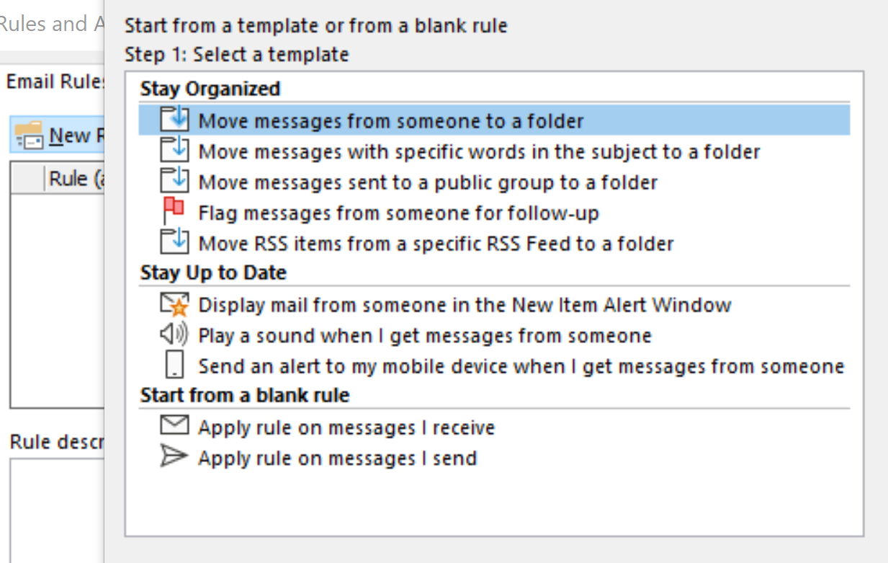

- Now you will need to select the conditions for the rule. Select “from people or public group” at the top of the list
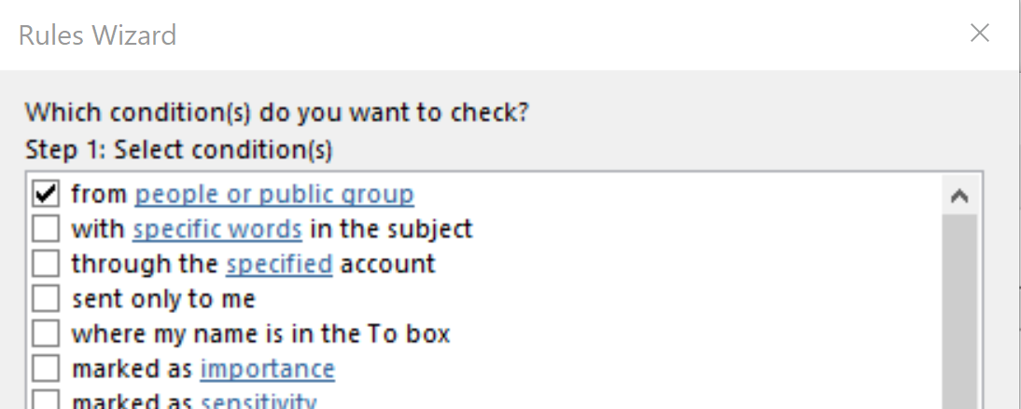

- Now at the bottom of the wizard select the highlighted text “from people or public group” then enter the address you would like to set the rule for at the box next to from.
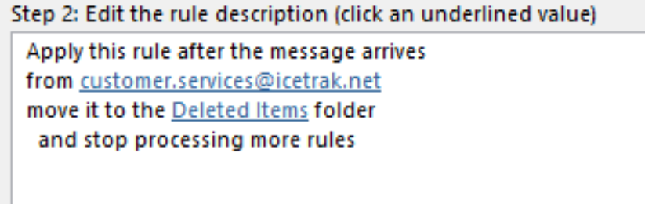
- Then select the highlighted text “specified” and select deleted items. Hit Ok to finish setting the rule
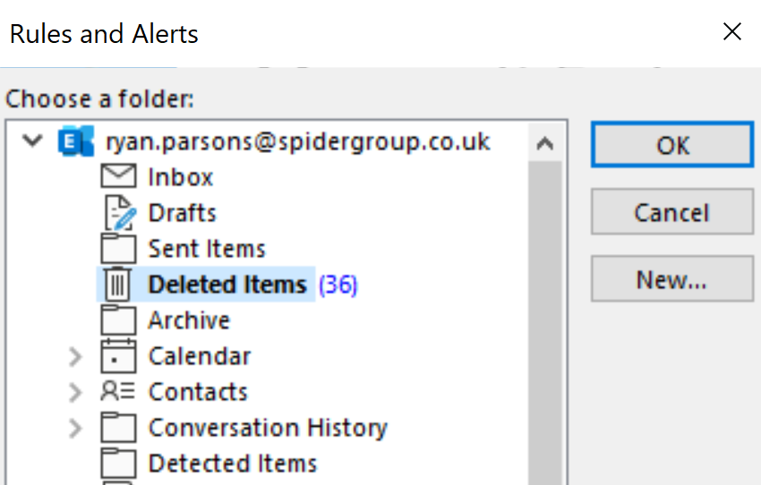

- Click finish and then Ok on the rule list.
